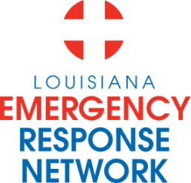

Louisiana Emergency Response Network
Board Meeting
November 20, 2014
1:00pm – 3:00pm
Location: Louisiana Emergency Response Network - Headquarters
14141 Airline Hwy, Suite One, Suite B Baton Rouge, LA 70817

AGENDA
1. Welcome LERN Board Members
2. Roll Call and Establish a Quorum
-Introduction of new board members
3. Approval of Agenda
4. Approval of Minutes of 8/22-23/14 Board Retreat
5. LERN Business:
- Executive Director Report P. Hargrove
- LSU Health Shreveport
- Rules and Regulations
- Blue Cross Meeting
- LERN App development
- Region 8 Trauma Center Meeting

b. Ratification of Commission Members P. Hargrove

c. Stroke Update Sheryl Martin-Schild, MD

d. Trauma System Update R. Coscia, MD
- Trauma Destination Protocol
- Trauma Program Attestation

e. Traumatic Head and Spinal Cord R. Gomez
Injury Trust Fund

f. Budget/Finance P. Sullivan/C. Woods

g. Proposed Meeting Schedule 2015 J. Hunt, MD

h. Dr. Hunt Report/Closing Remarks J. Hunt, MD

6. Public Comment
7. Adjournment
Next Board Meeting – January 15, 2015

